DIGITAL MARKETING

Assignment 4- Create an email newsletter and posting it in blog

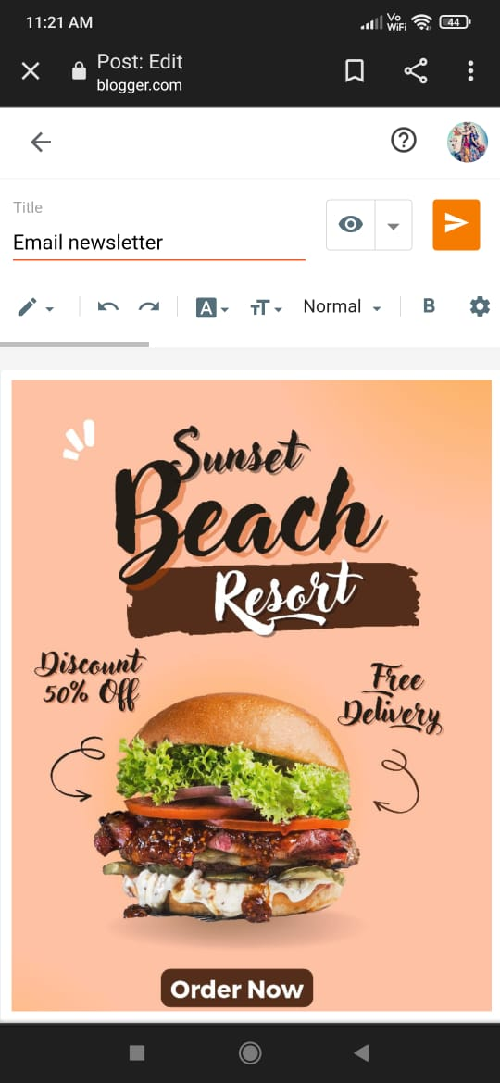

Figure: post on blog

Email newsletter:

<https://www.blogger.com/blog/post/edit/6415530707360594120/8075305478944748502>

Email newsletter:

